Experiment – 10
Write a Python Program to Implement Expectation & Maximization Algorithm.

Aim
To implement the Expectation Maximization (EM) algorithm in Python using the Gaussian Mixture Model (GMM) for clustering data and visualize the resulting clusters.

Algorithm
- Import the required Python libraries.
- Generate a sample dataset for clustering.
- Create a Gaussian Mixture Model (GMM) with the desired number of clusters.
- Fit the GMM model to the dataset using the Expectation Maximization algorithm.
- Predict the cluster labels for each data point.
- Obtain the cluster centers (means).
- Display the cluster assignments and cluster centers.
- Visualize the clustered data using a scatter plot.
- Interpret the clustering results.

Program:
# Step 1: Import Libraries
import numpy as np
import matplotlib.pyplot as plt

from sklearn.datasets import make_blobs
from sklearn.mixture import GaussianMixture

# Step 2: Generate Sample Dataset
X, y = make_blobs(n_samples=300,
centers=3,
cluster_std=0.8,
random_state=42)

# Step 3: Create Gaussian Mixture Model
gmm = GaussianMixture(
n_components=3,
covariance_type='full',
random_state=42
)

# Step 4: Train Model using EM Algorithm
gmm.fit(X)

# Step 5: Predict Cluster Labels
labels = gmm.predict(X)

# Step 6: Display Cluster Centers
print("Cluster Centers:")
print(gmm.means_)

# Step 7: Plot Clusters
plt.figure(figsize=(8,6))

plt.scatter(X[:,0], X[:,1],
c=labels,
cmap='viridis',
s=40)

plt.scatter(gmm.means_[:,0],
gmm.means_[:,1],
color='red',
marker='X',
s=250,
label='Centers')

plt.title("Expectation Maximization (Gaussian Mixture Model)")
plt.xlabel("Feature 1")
plt.ylabel("Feature 2")
plt.legend()
plt.show()

Output:
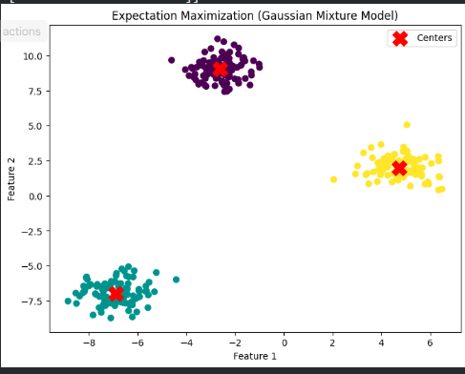

Result:
The Expectation Maximization (EM) algorithm was successfully implemented using the Gaussian Mixture Model (GMM) in Python. The algorithm effectively identified the clusters in the dataset and estimated their centers. The scatter plot confirmed that the EM algorithm successfully grouped similar data points into distinct clusters.

